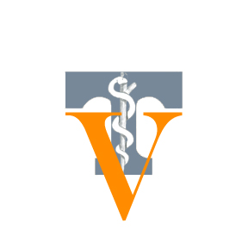
TENNESSEE VETERINARY MEDICAL ASSOCIATION

Please join us for
Veterinary Day on the Hill
Wednesday, February 17, 2016
8:00 am – 1:00 pm
Legislative Plaza, Nashville

This is our opportunity to educate legislators about the veterinary profession and about
the importance of veterinary medicine in the protection of public health.

About the Event:
- Opportunity to meet and talk with legislators from your district.
Don’t worry, we provide ‘talking points’ on current issues.
- Display tables set up in the common area at Legislative Plaza; materials will be available for legislators and their staff members about veterinary medicine and specialties within the profession.
- Wear your work apparel and bring your business cards.
- You don’t have to attend the entire length of time; if you are only available for an hour or 2, you can sign up for the time which you are available.
- Your colleagues and veterinary technicians are welcome to attend with you.

We need veterinarians from across the state to attend.
Your participation helps make this an impactful event.

Remember, advocacy is one of the most important services you receive as a TVMA member!

To confirm your participation, please contact the TVMA office at
931-438-0070 or green.delo@gmail.com.

